AutoTickGen – Auto Ticket Generator

Purpose 1

Location 1

Run Location 1

Source Code Location 1

How to change information for a ticket that AutoTickGen already creates daily 1

How to make AutoTickGen create a daily ticket for a new set of tasks 2

Guidelines for the ticket information in file TaskList.xml 2

EmailSubject 2

Priority 2

AssigneeID 3

RequestorID 3

TicketType 3

EmailCCs 4

Tasks 4

Log files to check if something goes wrong 4

Changing between Production Mode and Test Mode 5

Databases/Servers Used 5

# Purpose

AutoTickGen is a scheduled console program that generates SDiExchange Ticketing System tickets based on the ticket information in file TaskLists.xml. The original intent was to create daily reminders about tasks that need to be performed by the NetCom team for auditing purposes.

# Location

## Run Location

Program name: AutoTickGen.exe

Run Server: SDIWebSrv

Run Path: C:\Program Files (x86)\SDI\AutoTickGen

## Source Code Location

Vsfoundataions\InsiteOnline

InsiteOnline 3.1\ConsoleUtilities\AutoTickGen

# How to change information for a ticket that AutoTickGen already creates daily

1. Open file TaskLists.xml found in the same folder where the executable AutoTickGen.exe is. Please make a backup first, though.
2. All information for a ticket to be created is in the element <TicketInfo>.
3. Find the ticket information you’re looking for between the start and end <TicketInfo> tags and modify the appropriate data using the guidelines in this document. Probably the easiest way to find your ticket info is to look for the email subject in the EmailSubject tag.
4. Save the file. The next time AutoTickGen runs, it’ll read the new information. If not, you may have to stop the scheduled task then restart it for the new information to be read from TaskLists.xml.

# How to make AutoTickGen create a daily ticket for a new set of tasks

1. Open file TaskLists.xml found in the same folder where the executable AutoTickGen.exe is. Please make a backup first, though.
2. All the information for a ticket to be created is between the start and end tags of element <TicketInfo>.
3. The easiest way to create information for a new ticket is to copy an existing <TicketInfo> element from the starting tag <TicketInfo> to the ending tag </TicketInfo>, inclusive, then paste it right after the ending tag </TicketInfo> for one of the existing ticket info items.
4. Modify the tags within element <TicketInfo> using the guidelines in this document.
5. Save the file. The next time AutoTickGen runs, it’ll read the new information. If not, you may have to stop the scheduled task then restart it for the new information to be read from TaskLists.xml.

# Guidelines for the ticket information in file TaskList.xml

The ticket information for one ticket is found between the start and end tags <TicketInfo> of file TaskLists.xml found in the same folder where the executable AutoTickGen.exe is.

The elements within these tags and their descriptions follow.

## EmailSubject

This is the subject line of the email. AutoTickGen will add the prefix “AutoTickGen xxx – “ to whatever text you put here.

Example:

<EmailSubject>Check Servers – John Doe</EmailSubject> will show

“AutoTickGen – Ticket 12345 – Check Servers – John Doe” in the subject line of the email.

## Priority

The priority of the ticket. AutoTickGen will write whatever text you put here to the priority field of the ticket; it won’t verify that the text is a valid priority.

Priorities we currently use in the SDiExchange Ticketing System are:

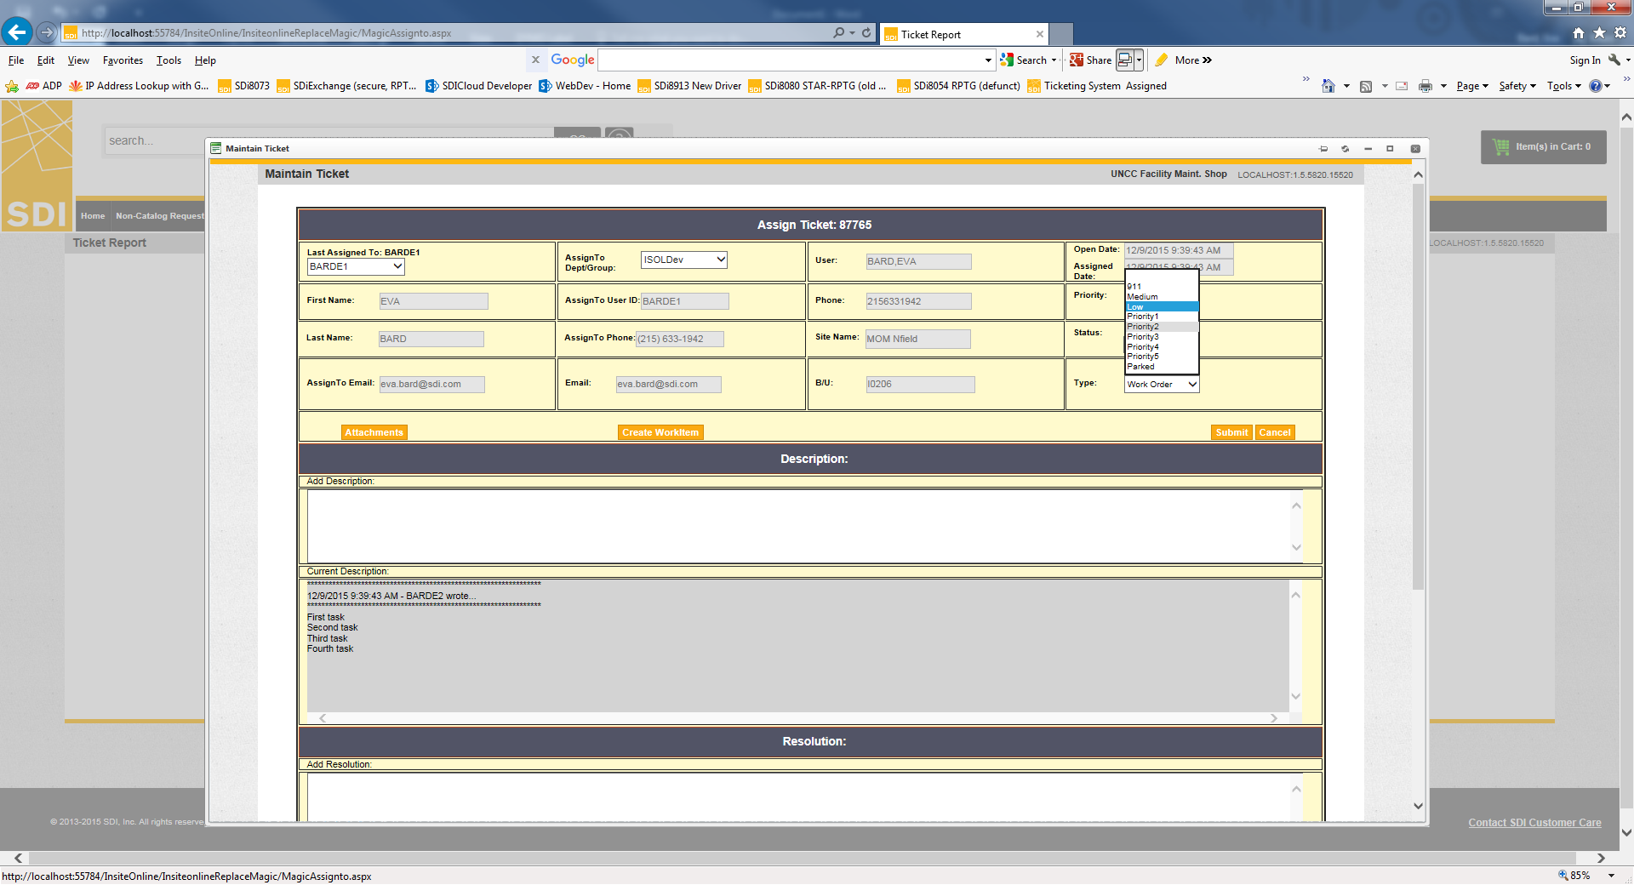

## AssigneeID

The user ID of the person/group that the ticket should be assigned to and to whom the email notification will be sent.

This must be a user ID in the SQL 2012 table m_user. The user ID must also exist in the SDiExchange Oracle users table ps_isa_users_tbl.

All the assignees we currently use in SDiExchange’s Ticketing System are properly set up so you can just check the SDiExchange Ticketing System dropdown under “Last Assigned to” in the ticket detail popup for any ticket to get the latest list.

Casing doesn’t matter.

Assignees we currently use in the SDiExchange Ticketing System are:

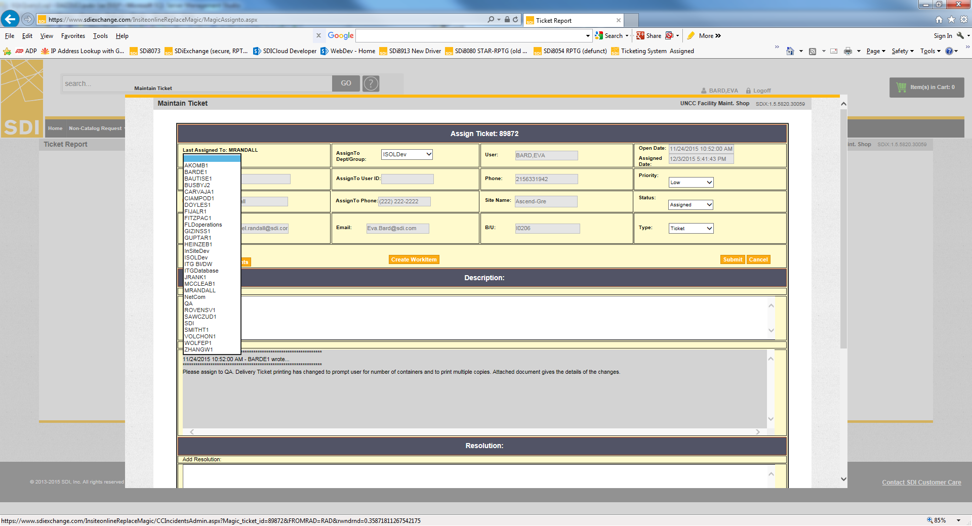

## RequestorID

According to the language in the SDiExchange Ticketing System, this is both the requestor and user.

The data you put here must be a user ID from the SDiExchange Oracle users table ps_isa_users_tbl.

You may check in SDiExchange’s Profile panel to get a valid user ID.

Casing doesn’t matter.

## TicketType

This is the type of ticket such as Ticket or Work Order. AutoTickGen will write to the ticket whatever text you put here; it won’t verify that the text is a valid ticket type.

Valid ticket types we use in the SDiExchange Ticketing System are:

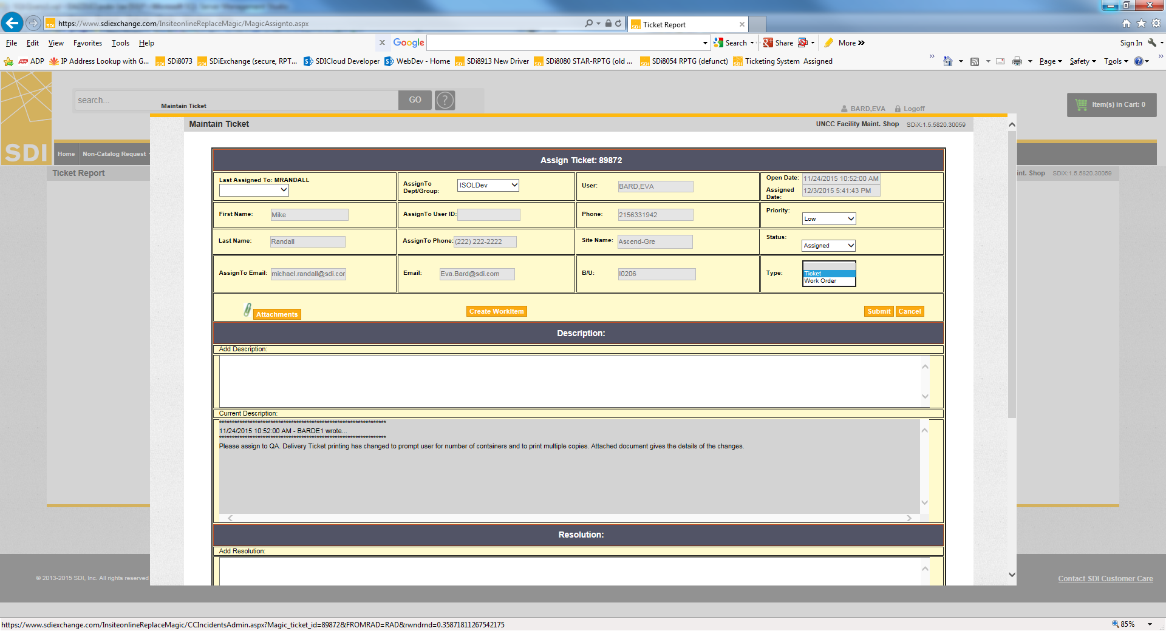

## EmailCCs

This is a list of either user IDs or email addresses that should be cc’d on the ticket email. You can include either a valid user ID from the SDiExchange Oracle users table ps_isa_users_tbl or an email address.

Be sure to separate multiple IDs/addresses with a semi-colon “;”. Additional spaces between the IDs/addresses and the semi-colon are fine.

Casing doesn’t matter.

## Tasks

This element encloses one or more <Task> elements that has a specific task you want included in description of the ticket.

If you want to add more tasks, just create another <Task>…</Task> tag pair and type the text of the task between the tags.

# Log files to check if something goes wrong

The log files are in a folder called Logs where the executable AutoTickGen.exe is.

The log file name is AutoTickGen_yyyymmdd_hhmmAM.log

Some contents of the file are:

“START Module1.ReadTaskFile”

The log file first records the name and path of the TaskLists.xml file.

“START Module1.LogTasks”

The log file then shows the contents of the TaskLists.xml that it read.

“START Module1.CreateTickets”

Finally, it shows information about the tickets it created including the ticket ID for each ticket and any errors creating the tickets.

# Changing between Production Mode and Test Mode

File AutoTickGen.exe.config has a key called “ProductionMode” which lets you change from using the production databases to the test databases. This is used primarily for testing an issue or code change without having to write “real” tickets to the production database.

To change between production and test mode, rename either file AutoTickGen.exe.configTEST or file AutoTickGen.exe.configPROD to AutoTickGen.exe.config. The correct settings for the test and production environments are in the respective config file.

If files AutoTickGen.exe.configTEST and AutoTickGen.exe.configPROD don’t exist, change between production and test mode as follows:

Edit file AutoTickGen.exe.config with Notepad. Set the key value to “True” for production mode and to any other value, such as “False”, for test mode.

At any time, except when the scheduled task is running, you can double click on AutoTickGen.exe to run and test the program. **Just be sure to run is as an administrator.**

## Databases/Servers Used

Production mode

SQL2012 server for SQL Server

PROD database for Oracle

Test mode

DAZZLE2 server for SQL Server

RPTG database for Oracle